# **FROM 16th July TO 23rd July**

# **Project ID:**

# **2021J_BV01_BCI Browser**

# **Project Title:**

# **Design and development of Brain Computer Interface Browser on Web and Mobile**

# **Summary:**

P300 spellers are among the most popular types of brain–computer interfaces (BCIs) and are extremely useful assistive devices that enable severely disabled patients to communicate. However, P300 speller performances should be further improved to translate laboratory designs into practical applications. We aimed to design a new speller paradigm that could evoke higher event-related potentials (ERPs) than traditional P300 spellers, thus improving the performance of BCI systems.

# **Detail:**

We are trying to make multiple matrices including the languages English and Hindi.

**METHODS-**

**P300 ENGLISH**

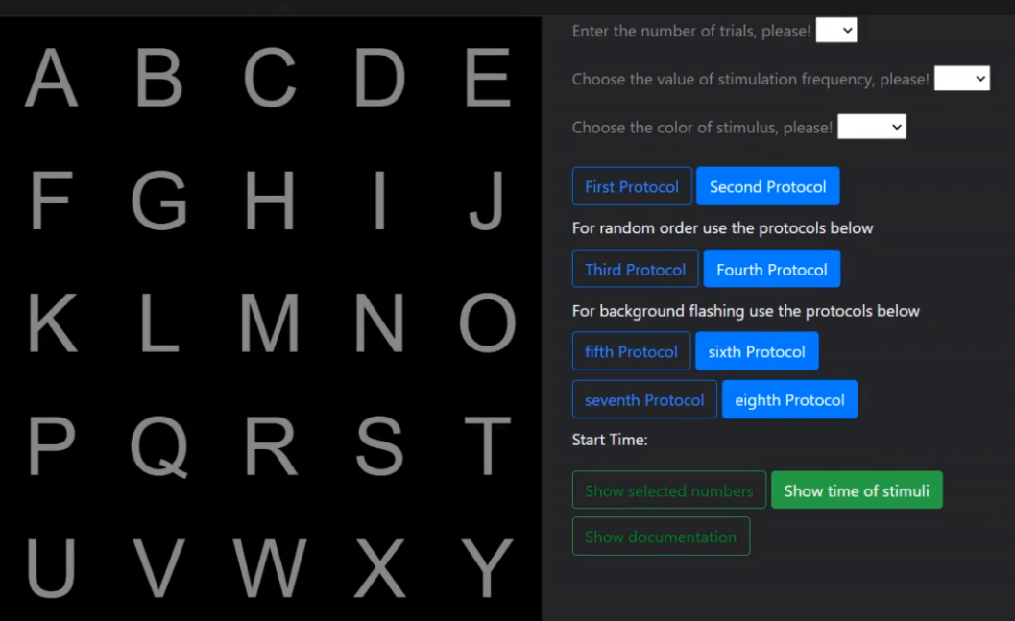

Given on the right are what the user has to select:

1.Number of trials

2.Value of simulation frequency

3.Color of the stimulus

After that there are 8 different protocol that the user has to choose from:

Protocol 1:- Flashes alternate rows

Protocol 2:- Flashes alternate letters

Protocol 3:- Flashes random rows

Protocol 4:- Flashes random letters

Protocol 5:- Flashes alternate rows in block way

Protocol 6:- Flashes alternate letters in block way

Protocol 7:- Flashes random rows in block way

Protocol 8:- Flashes random letters in block way

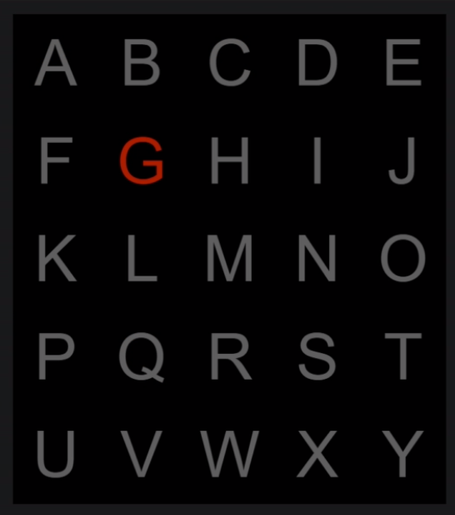

Fig:-Second protocol

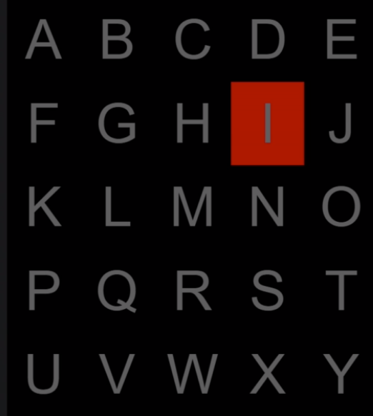

Fig:-Sixth Protocol

The Show selected numbers button shows us the column number or the row number that is flashed.

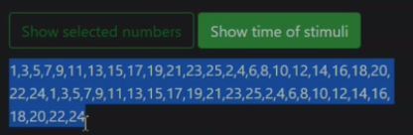

Show time of Stimuli button shows us the time in seconds and milliseconds at which each letter is flashed.

For e.g.:-



If my start time is at 36 mins past 10,

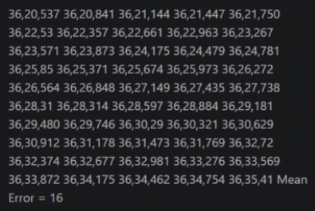

First character flashes at 36 minutes, 20 sec,537 millisecs and so on.

For the show documentation button,it shows the user which number stands for which column/row in which particular protocol

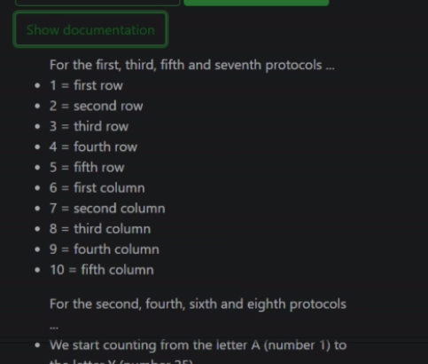

**P300 DEVANAGRI**

Similiar is the working of Devanagri matrix. To go to the Devanagri matrix, we’ve added an href link, clicking on which, we are redirected to that page.

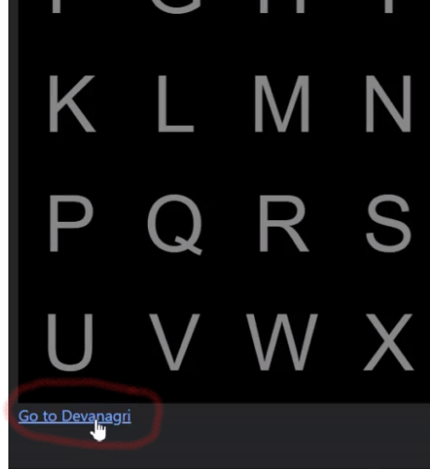

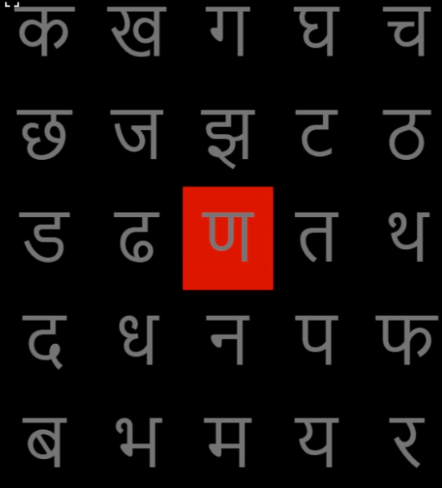

**CONCLUSION-:**

The skeleton application has been deployed on Heroku, but there are a lot of changes to make. We have to include all the letters of the English and Devanagri script, along with numbers and special characters. We have to make 2 different pages for the buttons and the matrix.